Report

Date | 18 September 2026
Team ID | MCA
Project Name | Smartphone Usage, Digital Addiction & Well-Being Analytics
Maximum Marks | 5 Marks

This report presents an analysis of digital addiction, smartphone usage, screen-time behaviour, and digital well-being using the Power BI dashboards provided. The analysis focuses on application usage, social-media usage, notifications, gaming, work/study hours, sleep, stress levels, and differences across age groups and addiction levels.
The dashboards provide interactive visualizations that help identify patterns in smartphone behaviour and understand how excessive digital engagement is associated with lifestyle indicators such as sleep and work/study time.

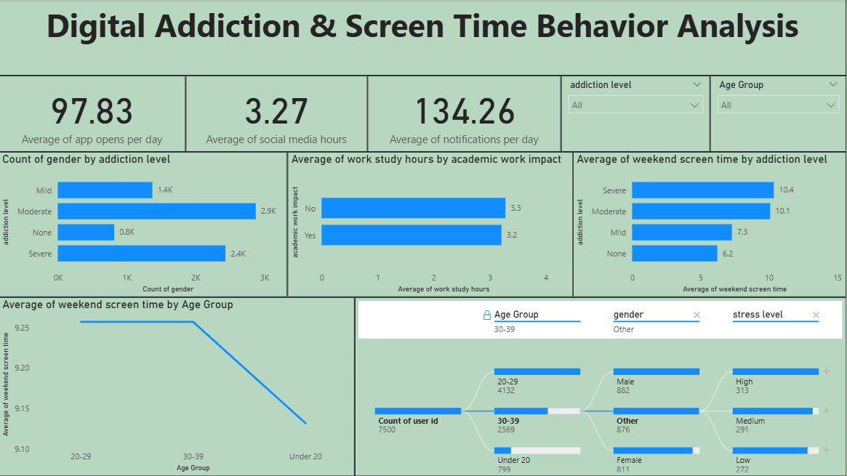
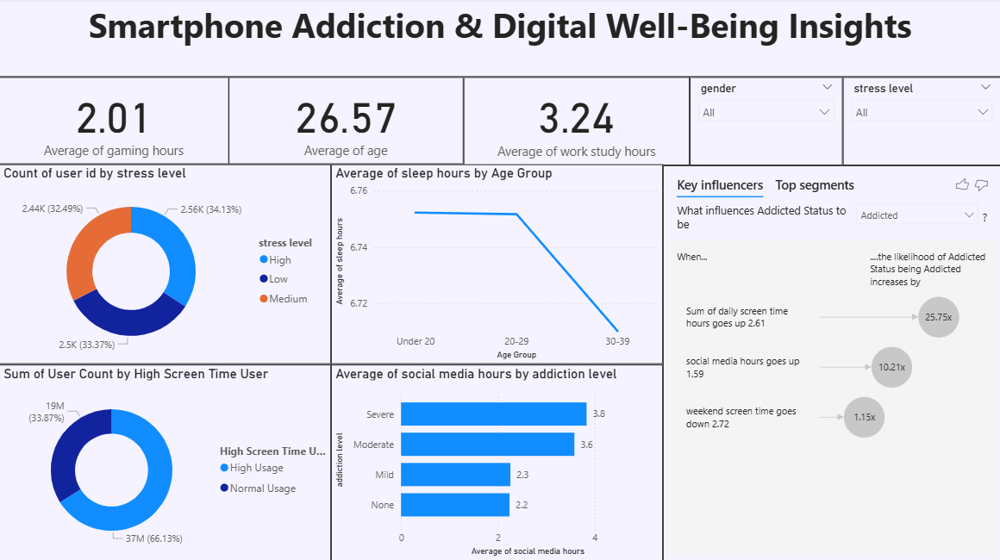
Observations drawn from reports in Power BI can provide valuable insights into user behavioral patterns and digital well-being trends.

1. Trends Over Time:
- Analyze how key metrics (e.g., app opens, notifications, and weekend screen time) change over different age groups to identify behaviour patterns or behavioral shifts across demographics.
2. Performance Comparisons:
- Compare performance across different categories, such as addiction levels (Mild, Moderate, None, Severe), to determine which areas are exhibiting the highest screen engagement.
3. Behavioral Segmentation:
- Assess demographic data (age group, gender, stress level) to understand target user profiles and customize digital wellness strategies accordingly.
4. Goal Achievement:
- Measure progress against established KPIs (Key Performance Indicators) like maintaining average sleep above 7 hours or reducing daily app interruptions to verify if digital balancing milestones are being met.
Example:
- Gender & Addiction Distribution:
- The gender distribution chart indicates that a significant user volume is highly engaged, with the Moderate addiction tier accounting for 2.9K users and the Severe tier tracking closely at 2.4K users.
- Age Group & Sleep Impact:
- Among the tracked segments, the 30-39 age group displays a sharp behavioral shift, maintaining an average weekend screen time benchmark of over 9.2 hours while their average sleep duration significantly contracts down to 6.72 hours.
- Stress Level Disparities:
- The user profile matrix indicates highly distributed stress segments, where High Stress captures the leading tier at 34.13% (2.56K users), while Medium Stress is closely positioned at 33.37% (2.5K users), reflecting an implicit intersection with severe screen dependencies.
- High Screen Time Issuance & Influencers:
- A total volume of 37M tracking points (66.13%) fall squarely under the High Usage segment. Key influencers reveal that the likelihood of an individual being classified with an Addicted Status scales aggressively by 25.75x when total daily screen hours expand by more than 2.61 hours.

